Enhanced for loop: For Each loop
walk through elements in an array or other collection types. processes one element at a time, from the first element to the last
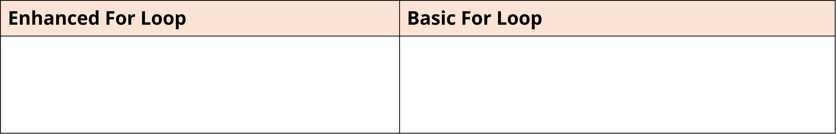
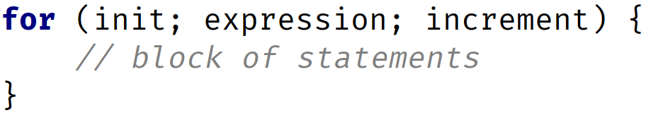
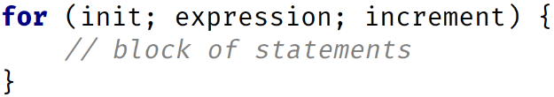
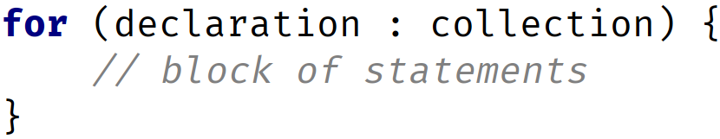

first part is a declaration expression which includes the type and a variable name
second component is the array

java.util.Arrays
little built-in functionality. inherits java.util.Object's functionality. single property or field, named length. toString method in this helper class prints out all the array elements, comma delimited, and contained in square brackets

